Office of Congressman Andy Harris, M.D. (MD-01)

Internship Program

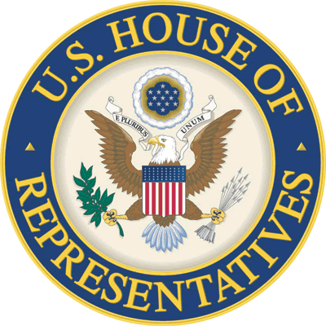

Internships are a wonderful opportunity for students to gain firsthand knowledge of Capitol Hill, the legislative process, and the unique communities and constituents of Maryland’s First Congressional District. Thank you for your interest in becoming an intern in the Office of Congressman Andy Harris, M.D.

Internships are offered on a part-time or full-time basis. The official office hours are from 8:30 a.m. to 5:30 p.m., Monday through Friday. We offer summer, fall, and spring internships. Intern applications are accepted throughout the year. Each office may support 2-3 interns per session.

Minimum requirements include:

* 2.8 out of a 4.0 GPA
* Willingness to work a minimum of two, four hour shifts per week
* Interpersonal communication skills
* A mature and responsible attitude
* Ability to multi-task and prioritize
* Strong writing and speaking skills
* Familiarity with Microsoft Office including Outlook and Excel

Priority is given to students from Maryland’s First Congressional District, but all applicants will be fully considered.

**General intern responsibilities may include:**

* Providing excellent service to constituents in-person and over-the-phone including greeting constituents and answering telephones
* Opening and directing mail
* Entering computer data
* Responding to constituent requests
* Leading United States Capitol Tours (DC)
* Escorting constituents to various Hill locations (DC)
* Attending congressional hearings and lectures (DC)
* Assisting with special projects, including legislative research
* Assisting with constituent casework (District Offices)
* Involvement with additional special projects important to the Congressman’s office

A Congressional Internship is a valuable way to understand Congressional office operations, the legislative process and the importance of serving others.

Please visit harris.house.gov for additional information, or feel free to call the office.

Office of Congressman Andy Harris, M.D. (MD-01)

2334 Rayburn HOB, Washington, D.C. 20515 – Main: 202.225.5311; Fax: 202.225.0254